
USN

Internal Assessment Test 1 – Apr 2026
Sub: | Analysis and Designs of Algorithms |  |  |  |  | Sub Code: | BCS401 | Branch: |  | ISE
Date: | 15-04-2026 | Duration: | 90 min’s | Max Marks: | 50 | Sem/Sec: | III / A,B,C |  |  |  | OBE
Answer any FIVE FULL Questions |  |  |  |  |  |  |  |  | MARKS |  | CO | RBT
1. | Design an algorithm to search for an element in an array using sequential search. Discuss the best case, worst case and average case efficiencies of the algorithm. |  |  |  |  |  |  |  | 10 |  | CO1 | L3
2. | Explain the general plan for analyzing the efficiency of recursive algorithms with an example. Also analyze the recursive Tower of Hanoi problem and derive its time complexity. |  |  |  |  |  |  |  | 10 |  | CO1 | L3
3. | Design a Quick Sort algorithm. Obtain its best case, average case and worst case efficiency. Apply the algorithm to sort a given list of elements. 5, 3, 1, 9, 8, 2, 4, 7. |  |  |  |  |  |  |  | 10 |  | CO2 | L3
4. | Explain Strassen's Matrix Multiplication. Apply multiplication to multiply the following matrices:  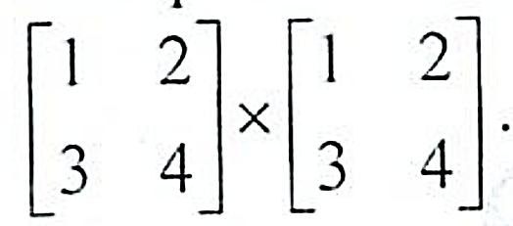 |  |  |  |  |  |  |  | 10 |  | CO2 | L3
5. | Explain the concept of Divide and Conquer. Design Merge Sort algorithm and derive its time complexity. |  |  |  |  |  |  |  | 10 |  | CO2 | L2
6. | Define AVL Trees. Explain its four rotation types. |  |  |  |  |  |  |  | 10 |  | CO3 | L2

CI CCI HOD

USN

Internal Assessment Test 1 – Apr 2026
 | Sub: | Analysis and Designs of Algorithms |  |  |  |  | Sub Code: | BCS401 | Branch: |  |  | ISE
 | Date: | 15-04-2026 | Duration: | 90 min’s | Max Marks: | 50 | Sem/Sec: | III / A,B,C |  |  |  |  | OBE
 | Answer any FIVE FULL Questions |  |  |  |  |  |  |  |  |  | MARKS |  | CO | RBT
1. |  | Design an algorithm to search for an element in an array using sequential search. Discuss the best case, worst case and average case efficiencies of the algorithm. |  |  |  |  |  |  |  | 10 |  |  | CO1 | L3
2. |  | Explain the general plan for analyzing the efficiency of recursive algorithms with an example. Also analyze the recursive Tower of Hanoi problem and derive its time complexity. |  |  |  |  |  |  |  | 10 |  |  | CO1 | L3
3. |  | Design a Quick Sort algorithm. Obtain its best case, average case and worst case efficiency. Apply the algorithm to sort a given list of elements. 5, 3, 1, 9, 8, 2, 4, 7. |  |  |  |  |  |  |  | 10 |  |  | CO2 | L3
4. |  | Explain Strassen's Matrix Multiplication. Apply multiplication to multiply the following matrices: |  |  |  |  |  |  |  | 10 |  |  | CO2 | L3
5. |  | Explain the concept of Divide and Conquer. Design Merge Sort algorithm and derive its time complexity. |  |  |  |  |  |  |  | 10 |  |  | CO2 | L2
6. |  | Define AVL Trees. Explain its four rotation types. |  |  |  |  |  |  |  | 10 |  |  | CO3 | L2

CI CCI HOD

